Time-Series Relationship Between Interest Rates and Equity Returns

Johns Hopkins University

Financial Econometrics [Time-Series Analysis]

Zhihao Zhang, David Mo, Chi Tang

# Abstract

Given the recent attention around interest rate increases spurred by Federal Reserve monetary policy, this paper looks to utilize the theoretical link between the effective federal funds rate and equity prices to create a vector autoregression forecasting model of the S&P 500 Index (^GSPC) and the Nasdaq Composite Index (^IXIC). A daily time series from 7/3/2000 to 9/7/2023 representing 5789 unique observations is used to examine this relationship. The empirical results suggest that simple vector autoregressive models pairing these 2 stock indexes with the effective federal funds rate are not appropriate as forecasting tools, with the Nasdaq failing in Granger Causality testing and the S&P 500 forecast having imprecise and inaccurate estimates. We identify a lack of daily fluctuations in the effective federal funds rate and the indirect relationship between the effective federal funds rate and equities as the primary issues within our model, and that different data series such as bond yield spreads may be more appropriate estimators of equity prices.

# Introduction

Following the societal lockdowns and economic disruptions of the COVID-19 pandemic, the Federal Reserve has been responsible for combating the uncharacteristically high inflation rates that resulted. Their primary tool for this task has been the ability to set the federal funds rate, which is the rate at which financial institutions can make overnight loans to each other in order to satisfy daily liquidity requirements. This interest rate is popularly regarded as a defining baseline for macroeconomic and financial market outcomes, to which the Federal Reserve has pursued a contractionary monetary policy strategy of increasing the federal funds rate in hopes of containing overheated components of the economy. Between the first announced rate hike on March 17, 2022, and the most recent rate increase on July 27, 2023, there have been 11 increases to the federal funds rate.[1] This has brought the rate from 0.08% to 5.33% in little more than a single year.

In this same period, equity markets have experienced declines from their historic peaks in late 2021. Although the beginning of this stock market downturn doesn’t align perfectly with the first interest rate hike, Adrian and Abbas (2022) shows that private sector participants were anticipating the rate increases from at least the end of 2021 or the beginning of 2022, which could have preemptively affected forward-looking assets such as stocks. Figure 1 and Figure 2 illustrate this decline for the S&P 500 Index (^GSPC) and Nasdaq Composite Index (^IXIC) respectively.

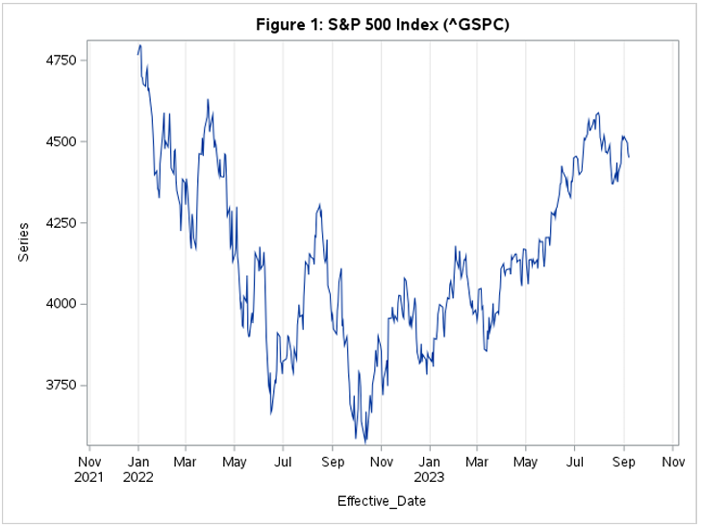

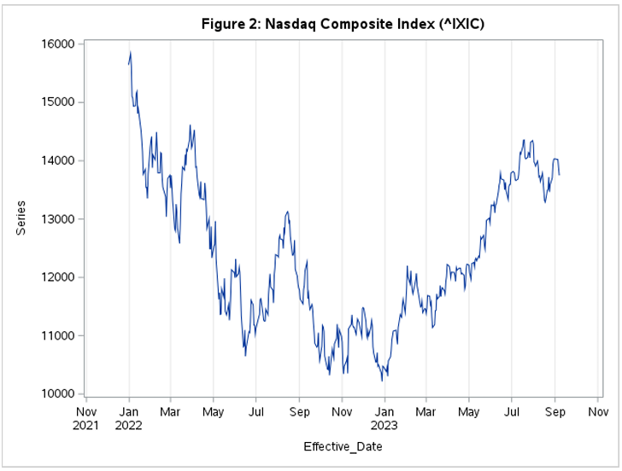

These time-series plots visually corroborate that there may be some correlation between interest rate increases and stock index declines, which is consistent with popular theories of financial markets. Nasdaq (2023) identifies 3 major impact vectors through which rising interest rates may impact equity prices: a wealth effect, a substitution effect, and a change in cash flow discounting.

The first effect, the wealth effect, stems from the federal funds rate’s status as a benchmark for all other interest rates in the economy. An increase in the federal funds rate would cause subsequent interest rates such as the prime rate also to increase, reducing companies' borrowing capacity as interest repayments on new debt become more expensive. This decreases firms’ profitability and capacity for pursuing value-adding projects, which hurts equity prices.

The second effect, the substitution effect, occurs due to the increased attractiveness of safer, debt-based securities such as bonds, treasury bills, and certificates of deposit. When interest rates increase, new issues of these securities will have higher interest payments. This increases both the demand for these securities and the required rate of return necessary for equities to maintain an appropriate risk premium over these safer securities. In this way, overall equity prices could decline via diverted funds lowering demand, and investors lowering the price they are willing to pay for risky assets.

Lastly, interest rate increases change firms’ discount rates. In determining stock valuations, the expected future cash flows of a company are incorporated through a discounted cash flow methodology. When the discount rate increases, future cash flows are discounted more heavily, which decreases firms’ present value estimates. This is mostly easily apparent in growth stocks, as much of their valuations are attributed to future earnings that lead these stocks to be susceptible to changes in discounting.

That said, there is evidently a strong theoretical link between interest rates and equity prices. However, the reverse relationship likely exists as well. For the Federal Reserve, rising equity prices may be an indicator of an overheating economy and subsequent inflation, to which it would need to respond by raising interest rates (Rigobon and Sack, 2003). If this is the case, then there arises an endogeneity problem when attempting to estimate the impact of interest rates on equity prices. Traditional OLS estimation would become biased under these circumstances, as there would be unobservable determinants of equity prices that are also correlated with interest rates. Therefore, acknowledging the presence of endogeneity between equity prices and interest rates, this paper seeks to explore the viability of utilizing the co-movements of these variables as a source of identification in vector autoregressive forecasting models. That is, can the linear relationship of these variables help construct an accurate forecasting model of equity prices. The general conclusion is that given the exact data and modeling used, these co-movements do not lead to accurate equity price forecasting.

# Literature Review

In the existing literature, an assortment of differing models have been utilized to estimate the effect of interest rates on equity prices. These research methods include various vector autoregression models like ours, along with more novel approaches such as heteroscedasticity-response models. The following analysis of this literature will first address the issue of endogeneity between stocks and interest rates and then explore the differing estimated results.

Providing a basis for our discussion of endogeneity between interest rates and equities, Rigobon and Sack (2003) tests whether the Federal Reserve’s monetary policy decisions respond to equity prices. They propose that the Federal Reserve, which is nominally only interested in inflation and output, views rising equity prices as an indicator of an overheating real economy. Potential reasons for this are the wealth effect of increasing portfolio values subsequently increasing aggregate demand, and higher stock prices increasing the ability of businesses to raise money via equity offerings. To test this, they use a heteroskedasticity response model that computes the response of short-term interest rates to changes in equity prices by shifts in the variance/ covariance matrix. With this method, they find a statistically significant response, where given a 5 percent rise in the S&P 500, the expected federal funds rate at the next FOMC meeting increased by about 14 basis points, and the probability of a 25 basis point increase rose by about 50%. This provides strong evidence of endogeneity.

Having identified this endogeneity, the subsequent literature that we analyze all implicitly acknowledges its existence through their chosen specifications. Rigobon and Sack (2004) continues on their previous research by estimating the opposite side of the relationship between stocks and interest rates using their heteroskedasticity-response model. Specifically, they use the variance/ covariance changes that occur on days of FOMC meetings and Federal Reserve testimonies to Congress. Their key finding was that the effect of interest rate policy decisions on equity prices was negative and statistically significant, with a 25 basis point increase in the three-month interest rate resulting in a 1.7% drop in the S&P 500, and an even larger drop in the Nasdaq of 2.4%. Additional findings were that these effects were experienced only on monetary policy action dates and that the effects were not heavily time-distributed as adding large amounts of lags to their models had little impact.

Paul (2019) and Assenmacher-Wesche & Gerlach (2009) both corroborate this negative relationship between stocks and interest rates with variations of the VAR model. In his study, Paul (2019) constructs a vector autoregression with exogenous shocks (VARX) by using monetary policy surprises as a proxy for actual structural monetary policy events. He finds that although there is a negative relationship between stocks and interest rates, this relationship varies across time. Assenmacher-Wesche & Gerlach (2009) alternatively uses both single-country VAR and panel VAR (VARP) specifications using inputs from 17 OECD countries. Through this analysis, they find that the negative impact of interest rates on equity prices is contemporaneous, but is transient such that stocks quickly return to their original levels.

# Data

To capture the relationship between interest rates and equities within a forecasting framework, our empirical model combines 3 variables, the effective federal funds rate, S&P 500 (^GSPC) adjusted closing prices, and Nasdaq Composite (^IXIC) adjusted closing prices, into a balanced time series from 7/3/2000 to 9/7/2023. These observations occur at a daily frequency, with 5789 individual observations recorded in this way. Table 1 provides descriptive statistics of the chosen variables.

**Table 1: Descriptive Statistics - Original Data**

|  |  |  |  |  |  |
| --- | --- | --- | --- | --- | --- |
| Variable | Obs | Mean | Std. Dev. | Min | Max |
| Effective Federal Funds Rate | 5789 | 1.65 | 1.84 | 0.04 | 7.03 |
| S&P 500 (^GSPC) Adjusted Close | 5789 | 1952.06 | 1037.29 | 676.53 | 4796.56 |
| Nasdaq (^IXIC) Adjusted Close | 5789 | 4864.13 | 3773.08 | 1114.11 | 16057.44 |
| Sources by variable:  [1] Effective Federal Funds Rate (EFFR): Federal Reserve Bank of New York <https://www.newyorkfed.org/markets/reference-rates/effr>  [2] S&P 500 Adjusted Close: Yahoo Finance <https://finance.yahoo.com/quote/%5EGSPC/history?p=%5EGSPC>  [3] Nasdaq Composite Adjusted Close: Yahoo Finance [https://finance.yahoo.com/quote/%5EIXIC?p=^IXIC&.tsrc=fin-srch](https://finance.yahoo.com/quote/%5EIXIC?p=%5EIXIC&.tsrc=fin-srch) | | | | | |

Although high-frequency data has the potential to produce excessive noise and be difficult to forecast, the choice to use data recorded at a daily frequency is motivated by several key advantages. The first is that we are able to capture the effects of monetary policy decisions on interest rates as they are announced. As identified by the previous literature, two important components of the impact of interest rates on equity prices are that the effects are contemporaneous and that they are most noticeable on monetary policy announcement dates. Furthermore, the use of daily data allows us to maintain a large sample size despite limited data. The effective federal funds rate has only been recorded since the year 2000, so a monthly or quarterly dataset would not be able to benefit from large-sample properties.

# Empirical Methodology

To conduct our forecasting analysis, we begin by proposing 2 separate specifications for forecasting the S&P 500 Index and Nasdaq Composite Index with the help of interest rate co-movements. Our chosen model is a VAR(P) for these 2 systems of equations, but qualification checks are used to determine the validity of this choice.

From here, we implement a Box-Jenkins structure that involves 4 key steps: Stationarity, Granger Causality, Model Selection, and then Forecasting. The first three steps ensure that the data is properly prepared for analysis and that we are utilizing the proper model. The forecasting step involves a backward forecasting methodology where we create a training/ testing split with our data. The first 100 periods are separated as a testing set, while the remaining observations are retained within a training set. This allows us to evaluate the performance of our forecasting model on hypothetical out-of-sample data. The motivation for utilizing the oldest 100 observations rather than the newest 100 is the general uncertainty that our relationships of interest are the same for the post-COVID and pre-COVID eras due to the time-varying effects found in Paul (2019). Further study may implement regime-switching capabilities to address this issue, but within the scope of this study, the beginning is more visually similar to the majority of the dataset so is preferred. Furthermore, we remain conservative in our expectations for our model to be able to fully capture the large degree of noise experienced in daily-frequency estimation, so we chose to use a minimally-sized testing set to avoid the issue of imprecision and large forecasting errors in far-off projections. If the results allow, further study may increase the forecasting time frame.

## Stationarity

At this stage of our analysis, we perform stationarity checks on our 3 variables of interest. We begin with a trend and correlation analysis of each variable consisting of visually inspecting the time-series plots, ACF, and PACF functions for signs of nonstationarities. The effective federal funds rate plot doesn’t show an obvious trend, but it has an ACF function that does not tail off. The S&P 500 and Nasdaq plots do show obvious time trends, and also have persistent ACF functions. These characteristics are clear signs of nonstationarities and suggest that differencing will be necessary.

After visually identifying nonstationaries in each of these time series, we proceeded to formally conduct Dickey-Fuller tests for unit roots to determine the appropriate degree of differencing. The tests on the level series corroborated the previous visual analysis, as all three of the time series were found to be nonstationary in their level form. Subsequent testing found that first differencing would be sufficient to achieve stationarity, with all three of the first-differenced time series passing the Dickey-Fuller specifications. Additional tests of the differenced series in their vector autoregression forms were conducted, in which stationarity was confirmed through a modulus of less than 1 for both sets of VAR models. From these results, we find that the effective federal funds rate, S&P 500 prices, and Nasdaq prices are integrated of order 1, and we proceed with the rest of our analysis using the first differences of these variables. It is important to note that after first differencing, each variable now has 1 fewer observation than its original level form.

## Granger Causality

In this third step, we conducted Granger Causality tests on the new first-differenced variables to empirically identify whether the effective federal funds rate is truly an appropriate addition to equity price forecasting models. We arrange the two separate vector autoregressions and test both systems with 5, 10, 15, and 20 lags. Table 2 shows the results for the Granger Causality Wald Tests.

|  |  |  |  |  |  |  |  |  |  |  |  |  |  |  |  |  |  |  |  |  |  |  |  |  |  |  |  |  |  |  |  |  |  |  |  |  |  |  |  |  |
| --- | --- | --- | --- | --- | --- | --- | --- | --- | --- | --- | --- | --- | --- | --- | --- | --- | --- | --- | --- | --- | --- | --- | --- | --- | --- | --- | --- | --- | --- | --- | --- | --- | --- | --- | --- | --- | --- | --- | --- | --- |
| **Table 2:** **Granger Causality Tests**   |  |  |  |  |  | | --- | --- | --- | --- | --- | | **Specifications** | (1) | (2) | (3) | (4) | | VAR(p) | p=5 | p=10 | p=15 | p=20 | | **S&P 500**  Chi-Square | 10.71 | 21.75 | 30.89 | 35.55 | | Pr > ChiSq | 0.0575* | 0.0164** | 0.0091*** | 0.0174** | | **Nasdaq**  Chi-Square | 6.22 | 12.02 | 15.99 | 19.28 | | Pr > ChiSq | 0.2858 | 0.2835 | 0.3827 | 0.5037 | |  |  |  |  |  | | *\*\*\* Pr<.01, ** Pr<.05, * Pr<.1* | | | | | |

From these results, we find a statistically significant relationship between the effective federal funds rate and S&P 500 prices at each of our chosen lags, but none of the tests on Nasdaq prices were found to be significant. This suggests that including the effective federal funds rate in a vector autoregression is appropriate for modeling the S&P 500, but not the Nasdaq. From here, numerous alternative specifications or data inputs could be considered, but for the scope of this paper, we will proceed to model the Nasdaq with an ARIMA model to create a pseudo-counterfactual model to the vector autoregression of the effective federal funds rate and S&P 500. By analyzing the predictive ability of utilizing only the Nasdaq’s own past values to predict future Nasdaq prices, we will have a rough idea of whether the vector autoregression improves estimates by comparison. Future study on this topic would involve vector autoregression and ARIMA specifications for both stock indexes to create true counterfactuals for the estimation improvement of the vector autoregression.

## Model Selection

In the previous section, we identified the use of a vector autoregression for modeling the S&P 500 and an ARIMA for modeling the Nasdaq. We now perform a model selection methodology to consider an array of candidate models in two steps. First, we analyze the partial autocorrelation (PACF) plots of our two variables. Where we begin to see the PACF disappear is a strong indication of the appropriate number of lags to employ. Then to complete our model selection, we compute our candidate models and determine the best model by comparing the AIC and SBC information criterion for each specification. Models with lower AIC and SBC scores are preferred to those with higher scores, with a preference for lower lag levels as identified by the literature should the minimum value of these two indicators occur at a different number of lags.

For the vector autoregression between S&P 500 prices and the effective federal funds rate, the partial autocorrelation function shows a noticeable decrease in significant spikes after 9 lags. This suggests that a VAR(9) is likely to be our best model. We then compute our VAR(P) model with lags 1 through 20, making 20 total VAR models with the results reported in Figure 3.

From this plot, we identify the minimum AIC at 16 lags, and the minimum SBC at 9 lags. The minimum SBC occurs at a lower lag level and is in agreement with our PACF analysis, so we determine that 9 lags is our best model and proceed to the forecasting step of our analysis with a VAR(9).

Moving to the ARIMA model of Nasdaq prices, the partial autocorrelation function shows a similar cutoff at 9 lags. Further testing the ARIMA models, we estimate ARIMA(P) models for 1 through 20 lags, both with and without an intercept. The results are shown in Figure 4 and Figure 5.

We find a minimum AIC at 15 lags and minimum SBC at 9 lags in both plots, with the no-intercept models providing marginally better results. Additional ARIMA(P, Q) models were considered but did not lead to better results. From this, we identify an AR(9) model with no intercept as our best model for forecasting Nasdaq prices.

## Forecasting

Having identified our best models for forecasting S&P 500 and Nasdaq prices, we train our models on the last 5688 observations in our dataset, which represents the dates 11/27/2000 to 9/7/2023. We then use these trained models to forecast the first 100 periods and compare the results to the observed values in our testing set, which covers the dates 7/5/2000 to 11/24/2000. Figure 6 and Figure 7 below illustrate the time paths of these projections, and Table 3 shows the forecasting error metrics. As these are backward projections, the X-axis is flipped such that projections for time T = 100 is the nearest forecast, and time T = 1 is the “furthest out” forecast.

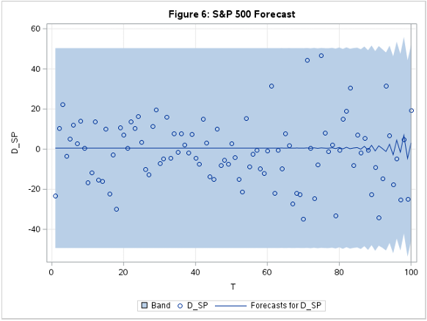

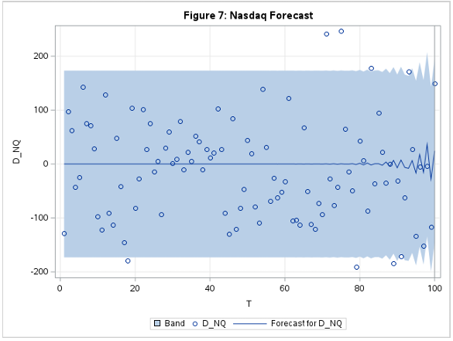

**Table 3: Forecasting Metrics**

|  |  |  |  |  |  |
| --- | --- | --- | --- | --- | --- |
| Variable | Obs | Sample Mean | Forecast Mean | MSE | RSE |
| S&P 500 (1st Difference) | 100 | -1.2777 | 0.5649 | 255.3368 | 1.0004 |
| Nasdaq (1st Difference) | 100 | -10.8755 | 0.1504 | 8509.0341 | 1.0000 |
|  | | | | | |

Interpreting these results, it is clear that our models are unable to accurately forecast S&P 500 and Nasdaq prices. Both forecasts suffer from imprecision and an inability to capture systematic patterns. This is visually seen by the wide confidence intervals, and projection time paths that do not “chase the data” and quickly converge to 0. Additionally, it does not appear that the vector autoregression of the effective federal funds rate and the S&P 500 performed better than the ARIMA model of Nasdaq, as the relative squared error (RSE) is about 1 for both forecasts.

One important issue that may have contributed to the poor estimation ability of our models and the absence of Granger Causality for the Nasdaq is a lack of daily variation in the effective federal funds rate. Due to changes in Federal Reserve policy, the effective federal funds rate, which began its time path as a free-floating variable that exhibited daily fluctuations, started to become much more stable in later periods. This change is especially noticeable in the post-COVID segment of the data, where the recent interest rate increases appear as a step-function that increases on monetary policy announcement dates but remains constant in between. The result of this is a lack of quality identification information for our vector autoregression model. Without a variety of data points from which to capture the co-movement between interest rates and stock indexes, the vector autoregression is not provided sufficient training to capture the link between these variables, and so suffers from inadequate inputs. In this way, the vector autoregression was essentially performing the same as an ARIMA model, since the additional input of the effective federal funds rate did not meaningfully add to the pool of identification information.

Another potential issue we identify is the indirect nature of the relationship between the effective federal funds rate and equity prices. Whether it is the cost of borrowing or the rate at which firms’ future cash flows are discounted, the effective federal funds rate is not the interest rate that is directly used in most economic activities. The Federal Reserve, however, only has the ability to directly set the federal funds rate. Their influence on market interest rates is therefore indirect and imperfect, which leads to a disconnect between the effective federal funds rate and the true interest rate that equities are responding to.

A possible solution to this in future study is to replace the effective federal funds rate with a bond yield spread such as the 10 Year-3 Month Treasury Yield Spread (I:10Y3MTS) or the spread between investment grade corporate bond yields and treasury bills. Not only are the level forms of these spreads better proxies for prevailing market interest rates, but they exhibit daily fluctuations due to being tradeable securities, and are forward-looking assets like stocks so can likely capture some of the same market expectations that influence the forward-pricing component of stocks.

# Conclusion

As the Federal Reserve’s interest rate decisions have been central to recent economic discussions, this paper sought to utilize the co-movements between interest rates and equity prices to produce vector autoregression forecasting models of the S&P 500 and Nasdaq stock indexes. To achieve this, we compiled a daily-frequency time series dataset spanning 5789 observations from July of 2000 to September of 2023 and proposed an identification strategy of two systems of vector autoregressions that paired the effective federal funds rate with each of the two stock indexes separately. The Nasdaq vector autoregression did not pass its Granger Causality test, while the S&P 500 vector autoregression did, which led us to proceed to forecast the Nasdaq with an ARIMA(9) and the S&P 500 with a VAR(9).

From our forecasting results, we found that both models suffered from a high degree of imprecision and inaccuracy as seen by large confidence intervals, poorly fitted prediction lines, and large error metric estimates. This is attributed to a lack of daily variation in the effective federal funds rate and the indirect nature of the relationship between the effective federal funds rate and equity prices. Future study will look to improve upon these results by utilizing various bond yield spreads as opposed to the effective federal funds rate, with the proposed benefits being a more direct relationship, market-determined daily fluctuations, and a similar forward-looking nature in both sets of securities.

# References

Adrian, T., & Abbas, N. (2022). “Low Real Interest Rates Support Asset Prices, But Risks Are Rising.” *IMF Blog.* <https://www.imf.org/en/Blogs/Articles/2022/01/27/blogs012822-low-real-interest-rates-support-asset-prices-but-risks-are-rising>

Assenmacher-Wesche, K., & Gerlach, S. (2008). “Financial Structure and Impact of Monetary Policy on Asset Prices.” *Center for Financial Studies (CFS) Working Paper, No. 2008/30.* <https://nbn-resolving.de/urn:nbn:de:hebis:30-57680>

Nasdaq (2023). “How do Rising Interest Rates Affect the Stock Market?.” *Nasdaq.* <https://www.nasdaq.com/articles/how-do-rising-interest-rates-affect-the-stock-market>

Paul. (2019). “The Time-Varying Effect of Monetary Policy on Asset Prices.” *Federal Reserve Bank of San Francisco* *working Paper 2017-09*, <https://www.frbsf.org/economic-research/publications/working-papers/2017/09/>

Rigobon, R., & Sack, B. (2003). “Measuring the Reaction of Monetary Policy to the Stock Market.” *The Quarterly Journal of Economics*, *118*(2), 639–669. <http://www.jstor.org/stable/25053916>

Rigobon, R., & Sack, B. (2004). “The Impact of Monetary Policy on Asset Prices.” *Journal of Monetary Economics, Volume 51, Issue 8, November 2004, Pages 1553-1575*. <https://doi.org/10.1016/j.jmoneco.2004.02.004>

1. The time scope of this paper extends to approximately Septmember of 2023, so the data used in this discussion does not reflect more recent developments.